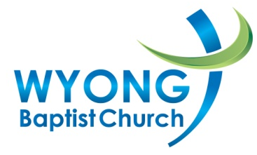

Work Health & Safety Policy

The Wyong Baptist Church recognises its moral and legal responsibility to provide a safe and healthy work environment for employees, voluntary workers and visitors and will endeavour to ensure that these people do nothing to place themselves or members of the public at risk of injury or illness.
The church will endeavour to:
- Provide a safe workplace including safe plant and systems of work
- Ensure compliance with legislative requirements and standards
- Provide workers, volunteers and contractors with information, instruction, training and supervision for their safety
- Provide support that will assist workers in maintaining their psychological and physical health
The church is responsible to:
- Provide a safe workplace
- To implement work health and safety policies and procedures
- Actively promote and be involved in the implementation of those policies and procedures
Workers are responsible for:
- Following all health and safety policies and procedures
- Reporting all hazards identified to the member of staff responsible for Work Health & Safety matters
- Complying with lawful instructions
- Not behaving in a wilful or reckless manner
The church is committed to encouraging consultation and cooperation between pastors, elders, ministry leaders, church administrators, employees and volunteer workers. It will involve all parties in workplace changes likely to affect their safety, health and welfare.

Approved:
Name / role: ………………………………………………….............................................................................................
.............................................................................................................................................................................
Date: ………/…………/………

