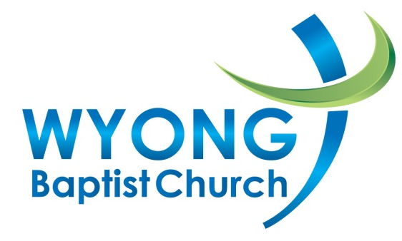

SAFE CHURCH POLICY
Protection of vulnerable people is our responsibility
Our mandate comes directly from God. God identified classes of vulnerable people who were to be protected and given special care and treatment in society because of their powerlessness (Exodus 22:21-22, Deuteronomy 10:17-19, Jeremiah 22:2-4, James 1:27).
This policy takes into consideration all vulnerable people in our church whether they be children, young people, elderly, those with disabilities or the emotionally and or spiritually vulnerable (i.e. those under the authority of church leaders).
We affirm that all people have the right to be emotionally and physically safe, respected, and have their views and opinions valued at all times.
We also live in a country that legislated for people’s safety, particularly in the area of child protection. Our policy has been developed to help us live out our Biblical mandate and our responsibilities under NSW legislation.
Our policy has the following goals:
To minimise the risk of abuse, ministry misconduct and the misuse of positional power within the church.
To ensure that cases of suspected abuse and ministry misconduct are handled in a consistent, unbiased and thorough manner.
To ensure that leaders and programs are safe.
To ensure that all people are respected and valued, irrespective of their gender, age, country of origin, cultural heritage, socio-economic background or ability.

Safe Leaders
* For the purposes of this document the term Leader is defined as Pastors, Elders, Ministry Leaders, Leaders, Paid and unpaid Staff and Volunteers.
We commit to:

a. Safe recruitment of leaders
We will screen all prospective *Leaders in our ministries, before they are appointed.
All *Leaders will be recruited using the Working With Children Check Guidelines.
We will have a minimum church attendance policy for all prospective *Leaders.

b. Adequate training of leaders
We require that all *Leaders attend an Introduction to Creating Safe Spaces (or SCTA endorsed) workshop and attend a refresher workshop every 3 years.
We require all *Leaders attend additional ministry-specific training as required by our church leadership.
Page 1

c. Continual supervision of leaders
We commit to ongoing leadership training, supervision and support for *Leaders
All *Leaders will agree to follow our Leaders Conduct Covenant.

d. Responding to breaches of the Law, allegations of risk of harm (abuse) and serious ministry misconduct
All *Leaders will report disclosures or suspicions of child abuse, according to NSW legislation by using the procedure in Responding to Kids @ Risk (i.e. mandatory reporting).
Contact Safe Church Team.
Allegations of abuse, breaches of the Law, or serious misconduct are to be referred to Manager Ministry Standards (Association of Baptist Churches of NSW & ACT) 1300 647 780.

Safe Programs
We commit to:

a. Emotionally safe environments
We will offer participants, including children, the opportunity to provide input in the programs and the activities in which they participate by fostering and valuing their ideas, and encouraging participation in all areas of the life of the church, as far as is sensible and practical.
We will obtain appropriate information relating to the program participants, including children’s health and family situation, to ensure that we are able to care for their physical and emotional needs.

b. Safe physical environments
All *Leaders will follow the Safe Church Procedures for Safe Physical Environments.
*Leaders will exercise a duty of care through the use of forms, checklists and templates in the Safe Church manual for establishment and maintenance of safe environments in our church.
A “Church Safety” Officer or team will be appointed to ensure that the following areas are incorporated into establishing and maintaining a safe physical environment; fire safety, building safety, first aid, food safety practices, risk assessment for activities, adequate ministry supervision for activities, transport, critical incident and emergency recommendations.
*Leaders are to complete a written Approval for Ministry form annually. * Leaders submit their forms to their Church leadership who grant ministry approval.
This Policy will be reviewed every 2 years.

Pastor___________________________ Date______________________________

Elder____________________________ Date________________________________
Page 2 222
Helpful Definitions
Safe Places
Take steps to keep vulnerable people safe from spiritual, physical, sexual or emotional abuse and/or bullying.
Friendly Places
Value, respect and include all people.
Safety Officer
Also known as risk management officer, responsible for the oversight of the implementation of this Policy.
Safe Leader
Has been through a recruitment process, understands responsibilities, is supervised, and is an accountable team player.
Safe Program
All risks have been assessed and events thought through and planned, these programs have had permission to proceed from their ministry coordinator (a role that may be undertaken by a pastor, elder, deacons or other senior leader)
Team Leaders
Responsible for individual teams and programs. They will jointly recruit team members and complete safety management plans and for their individual programs.
Team Members (and Junior Team Members)
Responsible for working with their team to minister to the context of programs.
Our Policy
Our policy applies to all pastors, elders, staff members and volunteer workers associated within the ministry of the Association of Baptist Churches of NSW and ACT. Our policy takes into account:
NSW
- The Ombudsman Act
- The Commission for Children and Young People Act
- Child Protection (Prohibited Employment Act)
- Children and Young Persons (Care and Protection)
- Children Legislation Amendment 2009

Page 3

MORE INFORMATION
Our Safe Church Policy is supported by:
- Creating Safe Spaces Recommendations
- Creating Safe Spaces Workshop Workbooks
- Keeping the Balance Leader’s Conduct Covenant
- Responding to Kids @ Risk Procedure

Association of Baptist Churches of NSW and ACT
Manager – Ministry Standards 1300 647 7801

Reporting Suspected Risk of Significant Harm (Abuse)
NSW: Child Protection Help Line 13 21 11
ACT: Care and Protection Services 1300 556 728

Counselling Help National:
Kids Help Line – 1800 551 800
Lifeline – 13 11 14
Child Abuse Prevention Service (24 hr) - 02 9716 8000
Family Crisis Centre (24 hr) – 02 9622 0522

Page 4

